Project Executable Files

Date | 25 September 2026
Team ID | SWTID-2026-9230
Project Name | LegalEase
Maximum Marks | 3 Marks

Project Executable Files
This section requires submission of all executable and deployable files for your project. Ensure all files are properly organized, named, and uploaded to the specified submission platform. The evaluator must be able to run or deploy your solution using the provided files and instructions.

Step 1: Submission Checklist

S.No | Item to Submit | Submitted (Yes / No / NA)
1 | Complete source code (all files and folders) | Yes
2 | README / Setup Guide (instructions to run the project) | Yes
3 | requirements.txt / package.json / dependency file | Yes
4 | Database schema / seed files (if applicable) | NA / not required for core flow
5 | Environment configuration file (.env.example or similar) | Yes; secrets kept out of source
6 | Deployed application URL (if hosted) | Not provided
7 | APK / Executable binary (if applicable for mobile/desktop apps) | NA
8 | Dockerfile / Containerization config (if applicable) | Not provided
9 | Test files and test results | Yes
10 | Demo video or walkthrough (if required) | Not provided

Step 2: File / Folder Structure
Provide an overview of your project's file and folder structure below:
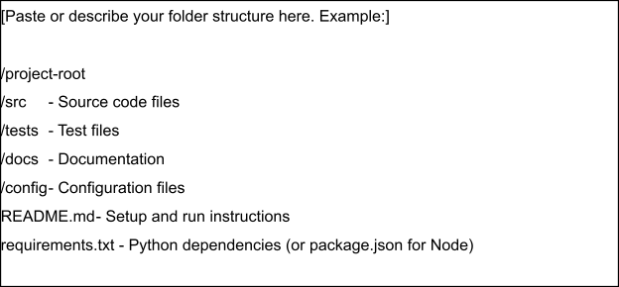

Step 3: Deployment / Access Details

Field | Details
Hosted / Deployed URL | Not provided
Login Credentials (Demo) | Not provided
Platform / Hosting Provider | Local / cloud-ready deployment; host not provided
Repository Link | Not provided
Demo Video Link | Not provided

Step 4: Run Instructions
Provide clear, step-by-step instructions for the evaluator to run your project locally:
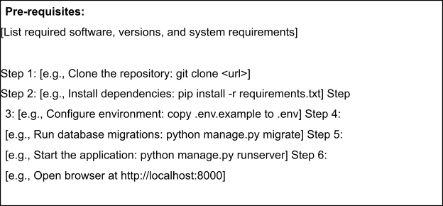

Step 5: Known Issues / Limitations

S.No | Known Issue / Limitation | Workaround / Status
1 | Dependency on Google Gemini API | Requires valid API key and available service
2 | AI output requires human review | Use generated content as a draft and review before legal use
3 | Production-scale hosting not specified | Deploy scalable infrastructure for larger usage

